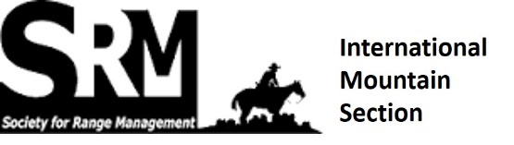

SRM IMS Award NOMINATION FORM

Trail Boss Award
The Trail Boss Award is the highest award bestowed by the International Mountain Section. The Trail Boss Award is intended to recognize individual IMS members who have demonstrated significant contributions in the science or art of rangeland management.

Excellence in Rangeland Management Award
The Excellence in Rangeland Management Award is given in recognition of significant contributions made by individuals or groups in the broadly defined discipline of rangeland management. This award is intended for individuals or groups who are directly involved in the management of rangeland.

Alicia Hargrave Award
The Alicia Hargrave Memorial Award is sponsored by the Hargrave family and the International Mountain Section to honour the memory of an extraordinary young rancher and range management professional. The Alicia Hargrave Memorial Award is given to a young woman who has shown promise early in her career to further the art and science of rangeland management.

Nominee’s Name:______________________________________________________________________

Recipient Address, phone, email:______________________________________________________________
__________________________________________________________________________________________

Nominated for the following award:

_________________________________________________________________________________

Nominated by (Name, Email, Phone): _____________________________________________________
______________________________________________________________________________________

Along with the Form, submit a letter of support or recommendation of how the recipient has demonstrated excellence.
Nominations to be sent to srm.ims11@gmail.com

Deadline for nominations: September 15, 2023

